**+MINOR PROJECT-01**

INTERNET OF THINGS AND ROBOTICS

**TOLL BOOTH**

**AIM** : To create an Embedded system to control the toll booth based on the distance of the car.

**CIRCUIT DIAGRAM**

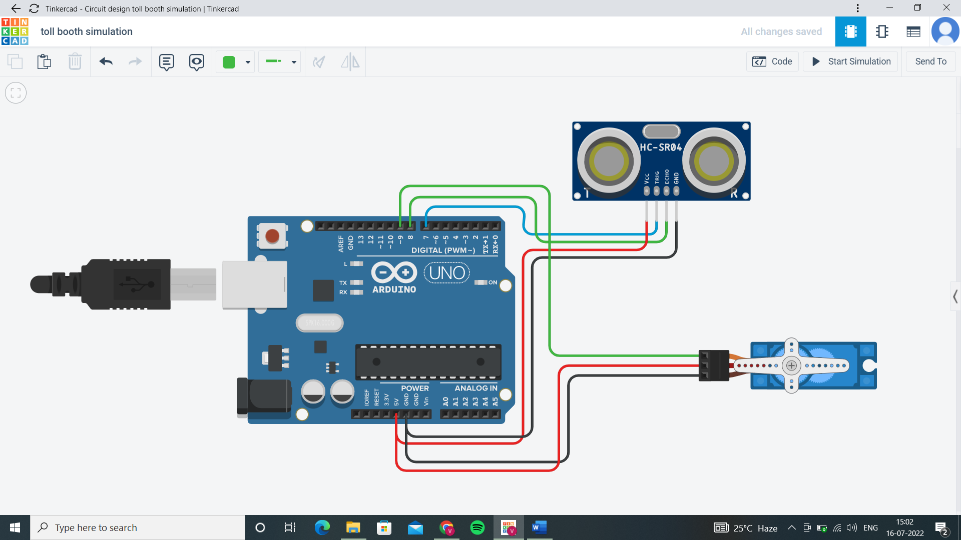

**CODE OF ENTIRE SYSTEM**

#include <Servo.h>

Servo toll;

float time;

float distance;

void setup()

{

pinMode(8,INPUT);

pinMode(7,OUTPUT);

Serial.begin(9600);

toll.attach(9);

toll.write(0);

}

void loop()

{

digitalWrite(7,0);

delayMicroseconds(2);

digitalWrite(7,1);

delayMicroseconds(2);

digitalWrite(7,0);

time=pulseIn(8,1);

distance=time*34650/(1000000*2); //speed of sound at 25˚C is 346.3 m/s

Serial.println(distance);

if(distance<=100)

{

toll.write(180);

delay(1000);

}

else if(distance>100)

{

toll.write(0);

delay(1000);

}

}

**NOTE:** Here I used delay of 1 sec to change direction of servo faster.

